19th January 2015

**YOKOHAMA to continue to support young drivers starting motorsport in UK**

***Following the success of George Russell in the 2014 BRDC Formula 4 Championship, running on YOKOHAMA control tyres, and subsequently going on to win the McLaren Autosport BRDC award, the UK distributor of Japanese high performance and motorsport tyres has confirmed its commitment to supporting young drivers on the first step on the ladder of opportunity.***

On the racetrack, the Junior Saloon Car Championship uses cars from the former SaxMax championship to allow drivers from 14 to 17 years of age to begin gaining their circuit experience. The cars are largely unmodified but with changes for safety and the series takes in circuits such as Rockingham, Brands Hatch, Oulton Park and Silverstone. The Junior Saloon Cars use the YOKOHAMA ADVAN A021R tyres for both wet and dry conditions.

On the rally stage, the Formula1000 series will also continue to run on YOKOHAMA ADVAN A048 tyres, with the field of 14-17 year-olds running over stages of single venue rallies between the main field, eliminating the speed and experience difference between older drivers and the younger ones. Cars here are typically one-litre Nissan Micras or Suzuki Altos.

The Next Big Step, as the name suggests, takes drivers from single venue predominantly tarmac events into the forests of the UK for their first taste of 'proper' rallying, on gravel and with trees just inches away. This is based on the same cars but set up for gravel stages and they will use YOKOHAMA's A035 gravel tyre as they tackle the four gravel and three asphalt events that make up the BTRDA Mixed Surface series. Drivers also get to make their own pace notes for the first time as they take part in the pre-event race.

This year, the scheme will also take former winner Aaron McClure further on, supporting him in the Group N Mitsubishi rally car he has procured to compete on the forest gravel stages, with a compliment of YOKOHAMA tyres to ensure consistency across the next phase of his competition.

And in Rallycross, the Suzuki Swift Juniors category of the British Rallycross Championship allows young drivers to enter the spectacular arena of rallycross, competing on both gravel and asphalt in the same race. The Juniors use 1300cc Suzuki Swifts and are fitted with ADVAN A048 control tyres as they race on the same bill as the rest of the British RX classes, including the Supercars.

Of course, this approach to supporting drivers as they begin their motorsport careers will run alongside the brand continuing its involvement with a huge array of series as control tyre supplier. Series such as the Atom Cup, Sports 2000, Caterham Graduates, Morgan and Mighty Mini series and several championships run by the 750 Motor Club will remain running on YOKOHAMA tyres as they have done for numerous seasons. The brand will also remain with the Scottish Mini Cooper Challenge and other series north of the border.

As it has in previous years, YOKOHAMA will continue as control tyre for the BriSCA Formula 2, Lightening Rod and Stock Rod categories of the hugely popular oval racing series. YOKOHAMA's sidecar racing tyres will also again be used in the Formula 2 category.

Commenting, Head of Motorsport at YHPT Ltd, Mark Evans, said; "I think 2015 is going to be a very interesting year for YOKOHAMA in motorsport. In addition to being used as control tyres for the FIA World Touring Car Championship for the tenth consecutive year, I am very excited about supporting young drivers as they take their first step onto the motorsport ladder.

"George Russell is an excellent example of how we can help fledgling drivers. His first season in car racing was on YOKOHAMA tyres and he did exceptionally well. He demonstrated excellent pace throughout, won the series and then was presented with the McLaren Autosport BRDC award - an amazing achievement in his first season in full circuit racing.

"That blueprint worked so well that we are committing to a similar approach in both circuit racing and rallying, with the Junior Saloon Cars and Formula1000 and The Next Big Step. I am very pleased to be working with these series to provide young drivers with a start into motorsport so that they can then progress their careers as far as possible.

"I am also pleased to continue working with so many series this year. We have been partners with virtually all of them for a number of years and I am pleased to be working with them again."

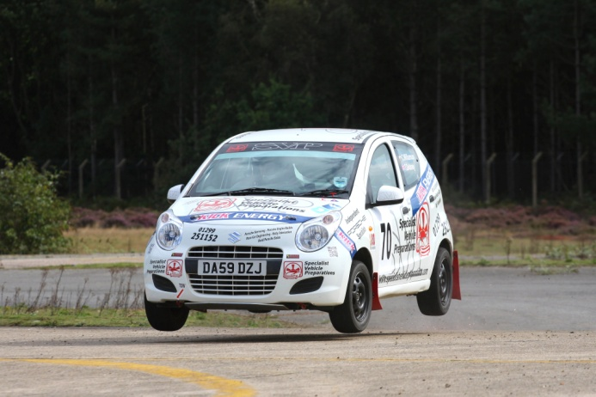

The Formula 1000 uses YOKOHAMA A048 tyres

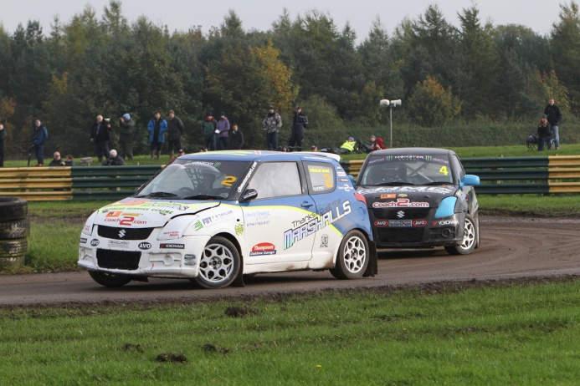

Suzuki Junior class of Rallycross also uses ADVAN A048 tyres